1. Create a SSIS package the generate below column csv file.

Customer Name | First Order Date | Latest Order Date | total Unique Order| Total Sale | Total profit

2.Create a SSIS package that generate category wise csv file

Hint: Determine how many distinct category is there in source file and there are 3 conditions – Furniture, Office supplies and Technology.

3. Create a SSIS package that display customer name with customer ID

4. Create a SSIS package that display all customer name in capital and all product name in small latter.Q.No.1 Create a SSIS package the generate below column csv file.   
Customer Name | First Order Date | Latest Order Date | total Unique Order| Total Sale | Total profit

Ans:

Output:

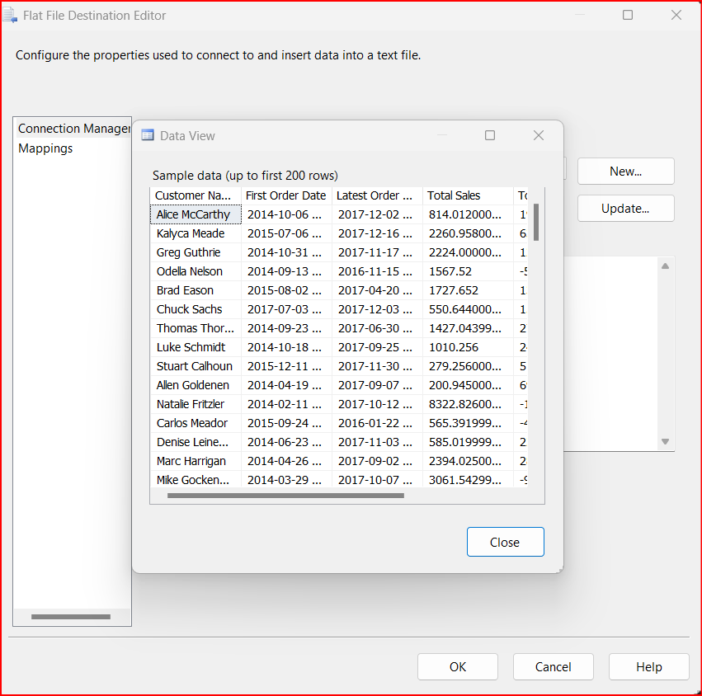

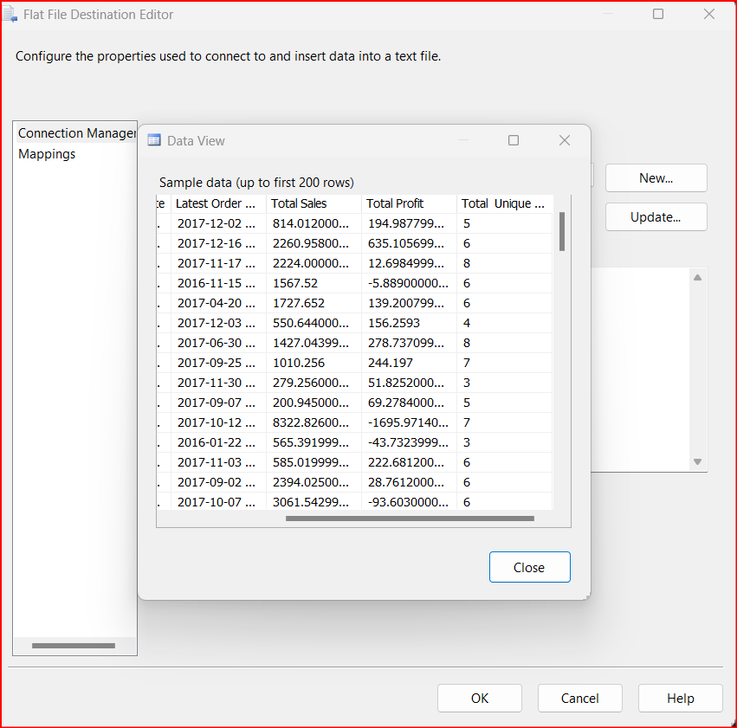

Execution:

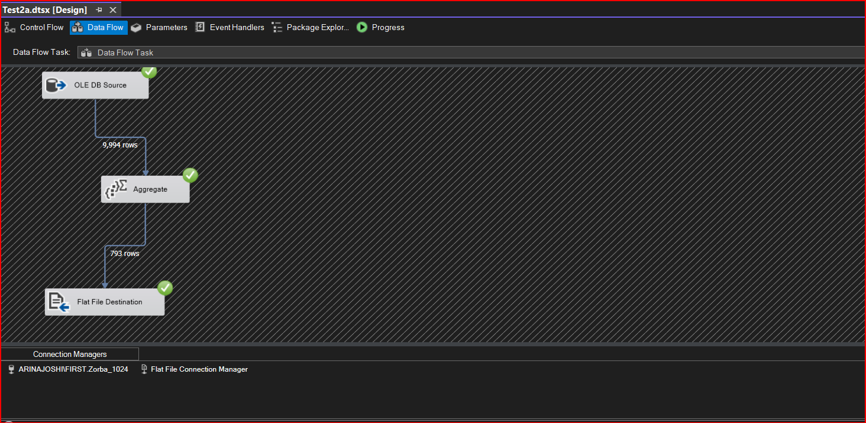

Question No.3 Create a SSIS package that display customer name with customer ID

Ans:

Output:

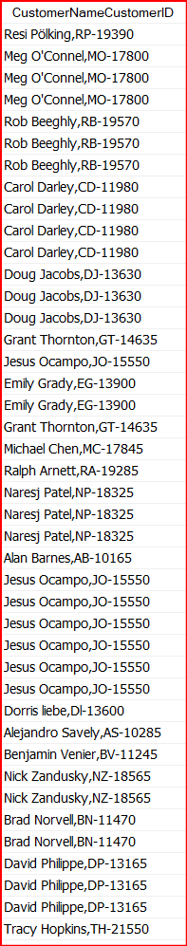

Execution:

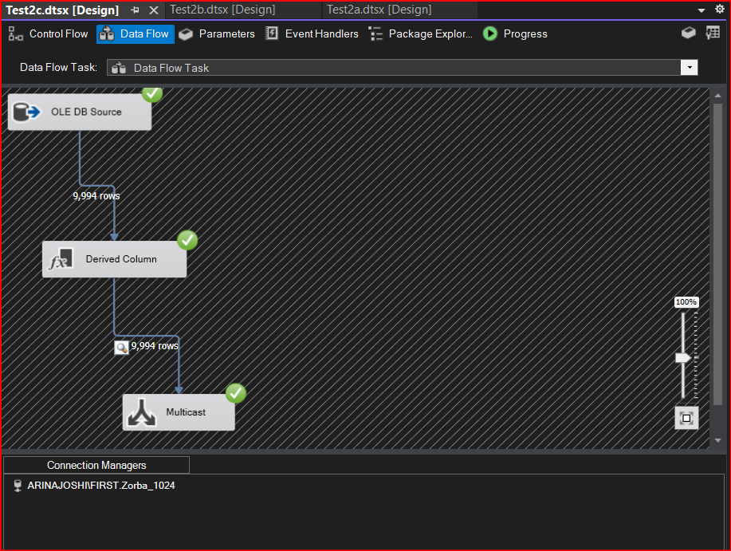

Question No.4 Create a SSIS package that display all customer name in capital and all product name in small letter.

Ans:

Output:

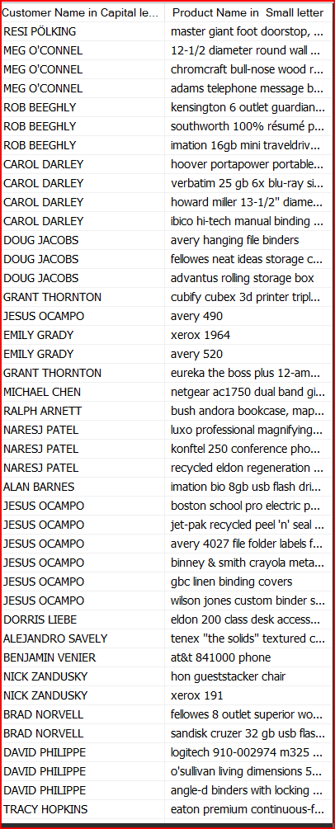

Execution:

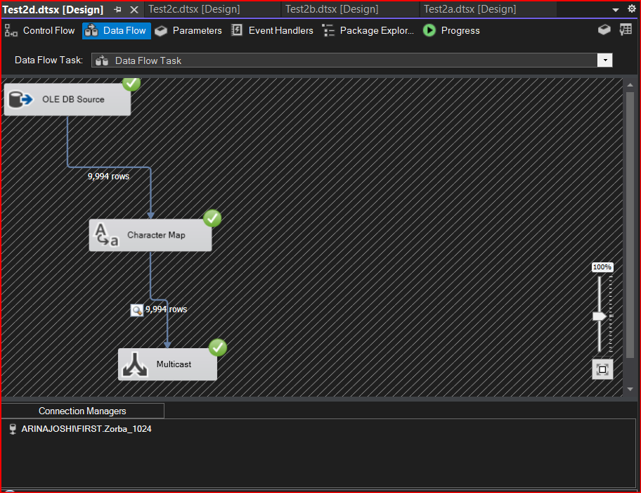

Question No.2 Create a SSIS package that generate category wise csv file

Ans:

Output:

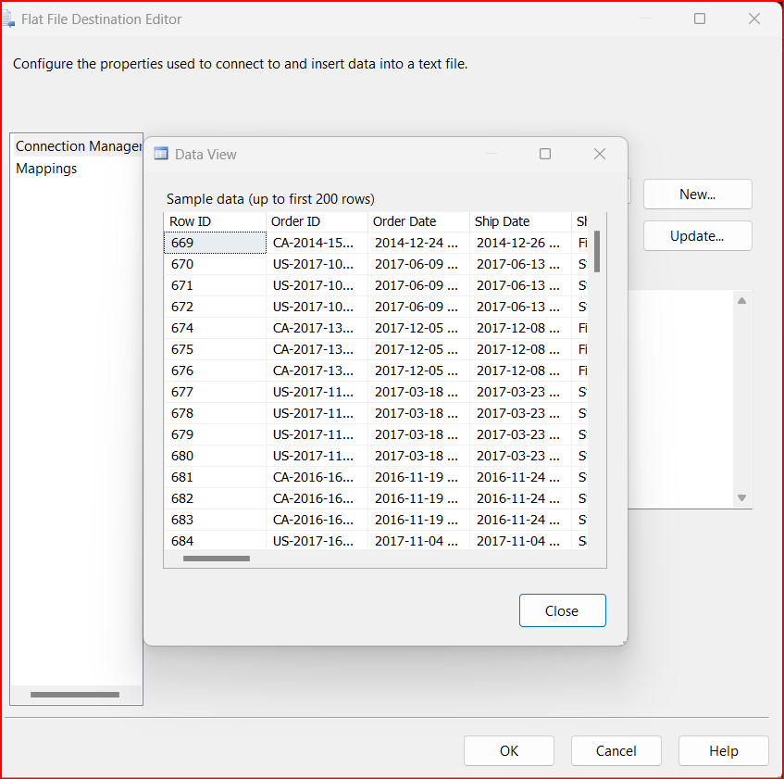

Execution:

